**Battle of Neighbourhoods for Food Truck Establishment in Bangalore**

**Introduction:**

The city of Bangalore has beautifully combined its rich cultural heritage with its technological and industrial accomplishments. In fact, this blend of traditions with the modern culture has made Bangalore one of the most happening cities in India. It is also called Silicon Valley of India. With people migrating from all kinds of multicultural background of India, Bangalore has been accommodating in every aspect. In the recent past, Bangalore may have evolved into a modern city adopting a lot of western ideologies, but the people of this city have clung on to its food heritage. There has been a drastic change in the city in terms of its infrastructure, transport facilities, population etc.

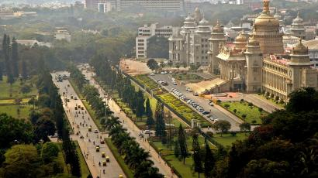

Owing to these changes, the kind of food culture that exists in the city has opened to a wide range of varieties catering to the different people hailing from different cultures. Along with the trend many people are open to trying different cuisines at different locations. There fore food catering industry has evolved into a competitive industry on a global level. Day by day many restaurants, cafes and bars are becoming innovative and creative in their form of delivery for customer satisfaction. With the recent era of “rating” this is justifiable. One of those trendy and innovative concepts is “Food Trucks”.

From the moment we invented streets, there have been street vendors. All you need is a good product, access to fire, a cart with sturdy wheels and you've got a business on your hands. Since then entrepreneurs have been investing in food trucks, carts, stands and all kinds of other mobile vending solutions. This has gradually shifted focus from ambient oriented food business which used to be so 2000.

**Business problem/Solution:**

The goal is to find an area to set up food truck in Bangalore To do that I want to build my business in the centre of the other accessible and running food trucks already exist, and. I will be using K-Means to find the average location of all the food truck locations and build my store there.

Anyone who wants to open a highly competitive and affordable food truck would be interested in the data.

**Data:**

Using Foursquare and geolocator the latitudes and longitudes of Bengaluru also called as Bangalore was taken out. Now that we have the city map, the data needed to complete this task is the location of the other food truck and small stores setup which are available online. These can be accessed through the Foursquare API as taught in week 2 also using the general customer id for food truck in foursquare for easy processing of data. The data I call from the API will the name of the business, as well as the latitude and longitude of the store in a radius of 500.